What is Field Injection?
👉 Field Injection means:
- Dependency is injected directly into the variable
- Uses @Autowired on the field
- No constructor
- No setter
💡 Easiest to write, but NOT recommended for real projects

🛠️ Step 1: Create Spring Boot Project in STS
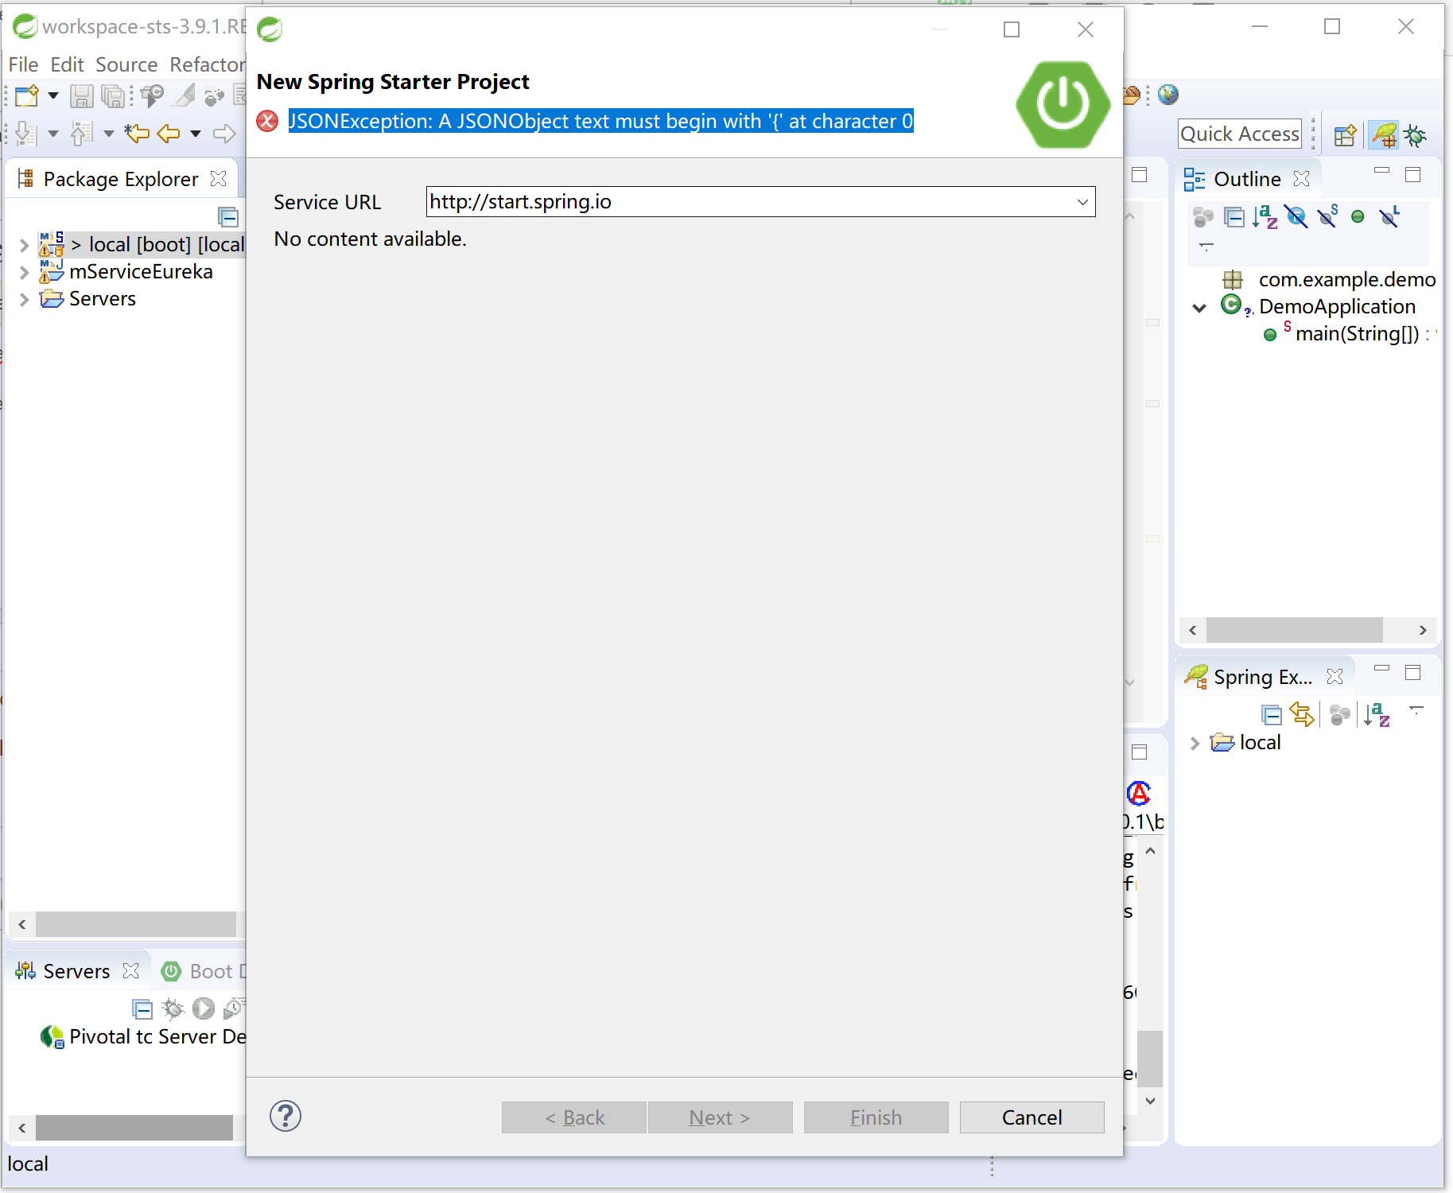
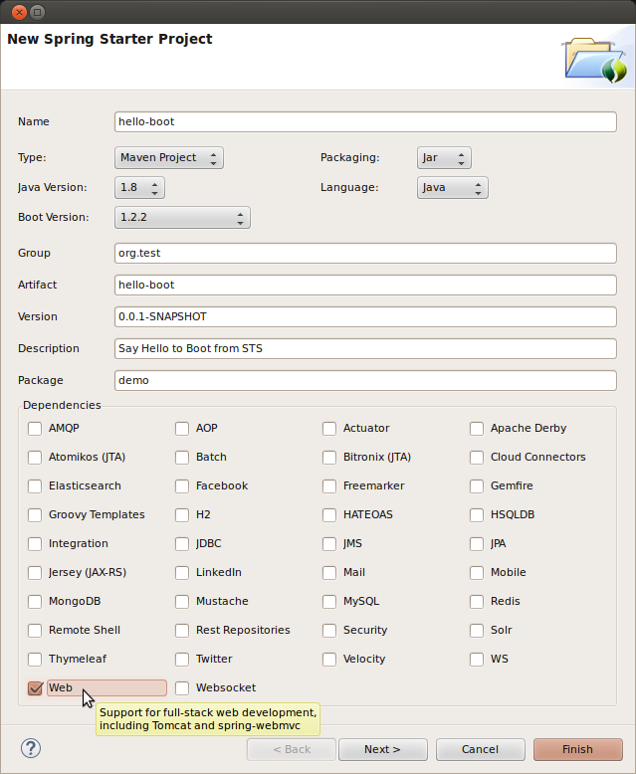
- Open STS
- File → New → Spring Starter Project
- Details:
  - Name: FieldInjectionDemo
  - Type: Maven
- Click Next
- Select:
  - ✅ Spring Web
- Click Finish

📁 Step 2: Project Structure
FieldInjectionDemo
└── src/main/java
└── com.example.demo
└── FieldInjectionDemoApplication.java

📶 Step 3: Create Dependency Class (SimCard)
📍 Package: com.example.demo
👉 Right-click → New → Class → SimCard
package com.example.demo;

import org.springframework.stereotype.Component;

@Component
public class SimCard {

public String connect() {
return "📶 SIM card connected to network";
}
}
🔍 Explanation
- @Component → Spring creates SimCard object
- connect() → real-world SIM functionality

📱 Step 4: Create Main Class (MobilePhone) with Field Injection
👉 Create new class
Name: MobilePhone
package com.example.demo;

import org.springframework.beans.factory.annotation.Autowired;
import org.springframework.stereotype.Component;

@Component
public class MobilePhone {

@Autowired
private SimCard simCard; // 👈 Field Injection

public void makeCall() {
System.out.println(simCard.connect());
System.out.println("📞 Making a call...");
}
}

🔍 Important Fresher Notes
✔ @Autowired directly on variable
✔ No constructor
✔ No setter
✔ Spring injects dependency using reflection

▶️ Step 5: Modify Main Application Class
Open
FieldInjectionDemoApplication.java
package com.example.demo;

import org.springframework.boot.SpringApplication;
import org.springframework.boot.autoconfigure.SpringBootApplication;
import org.springframework.context.ApplicationContext;

@SpringBootApplication
public class FieldInjectionDemoApplication {

public static void main(String[] args) {

ApplicationContext context =
SpringApplication.run(FieldInjectionDemoApplication.class, args);

MobilePhone phone = context.getBean(MobilePhone.class);
phone.makeCall();
}
}

▶️ Step 6: Run the Application
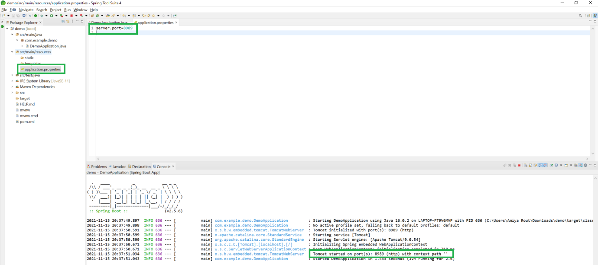
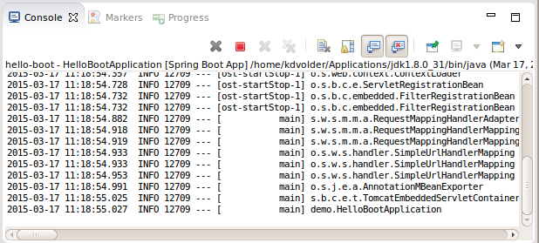
- Right-click project
- Run As → Spring Boot App
- Watch Console

✅ Expected Output
📶 SIM card connected to network
📞 Making a call...
🎉 Field Injection works successfully!

🔄 What Spring Did Internally (Simple Flow)
- Spring created SimCard
- Spring created MobilePhone
- Spring directly injected SimCard into field
- No constructor / setter used

⚠️ Why Field Injection is NOT Recommended (Important)
Problem | Reason
Hard to test | Cannot inject mock easily
Hidden dependency | Dependency not visible
Breaks immutability | Field can change
Reflection usage | Less safe
📌 Spring team recommends Constructor Injection instead

⚖️ Comparison of All 3 Injections (Easy Memory Table)
Injection Type | How | Use Case
Constructor | Constructor | Mandatory dependency ✅
Setter | Setter method | Optional dependency 🔁
Field | Direct field | Simple demos only ⚠️

📝 Final Summary (Remember Forever)
- Field Injection = @Autowired on variable
- Easiest to write
- Least recommended
- Good for learning, avoid in production

